Consolidate Tasks

UNIVERSITY OF LAW

Submitted by - Satinder singh

Submitted to - Callum Altham

Contents
1. AI Evolution and Paradigm Comparison 3
Timeline mapping of AI development 3
Symbolic versus subsymbolic AI comparison 3
2. Unit 4: Intelligent Agents and Task Environments 4
Task 1: defining key concepts 4
Task 2: analysing task environments through PEAS and environment properties 5
Task 3: agent design comparison 7
Task 4: critical thinking essay on surveillance agents 8
3. Unit 5: Search Concepts, Problem Formulation and Search Algorithms 10
Task 1: concept mapping 10
Task 2: formal problem formulation 10
Task 3: search algorithm analysis 11
4. Activity 3: Data-to-Decision Mapping 13
5. Unit 6: Prediction in Daily Life and Algorithm Selection 15
Activity 1: prediction in daily life 15
Activity 2: algorithm selection 16
6. Unit 7: Perceptrons, Activation Functions and Neural Architecture 18
Activity 1: perceptron calculation 18
Activity 2: function approximation 19
Activity 3: network architecture design 20
7. Unit 8: LLM Exploration, Prompt Engineering and LLM Limitations 23
Activity 1: LLM exploration 23
Activity 2: prompt engineering 24
Activity 3: LLM limitations 25
8. Conclusion 27
References 28

1. AI Evolution and Paradigm Comparison

Timeline mapping of AI development
The AI development journey could be seen as a progression of hopes and dreams and technological advances and failures, trying to achieve ‘human-level' machine intelligence, where initial optimism about what was achievable never happened due to a lack of computing power, data, and the ability to generalise models (Turing, 1950). From the timeline, you can understand that modern AI is not a single thing, rather four things that solve the parts of the intelligence problem – symbolic reasoning, statistical learning, neural networks, search, reinforcement learning, and transformer-based language modelling (Russell and Norvig, 2021). The AI winters are significant because they show how unrealistic claims and a lack of evidence for evaluation and deployment can lead to a decrease in funding, even though the scientific issues are interesting (Crevier, 1993).
The most important long-term architecture was attention-based sequential modelling in 2017 (Vaswani et al., 2017), which was more efficient in creating contextual representations compared to previous recurrent architectures. Transformer-based models (Brown et al., 2020) impact not only the performance and capabilities of this event, but also how contemporary generative AI, prompt engineering, multimodal models and discussions about AI governance are shaped.
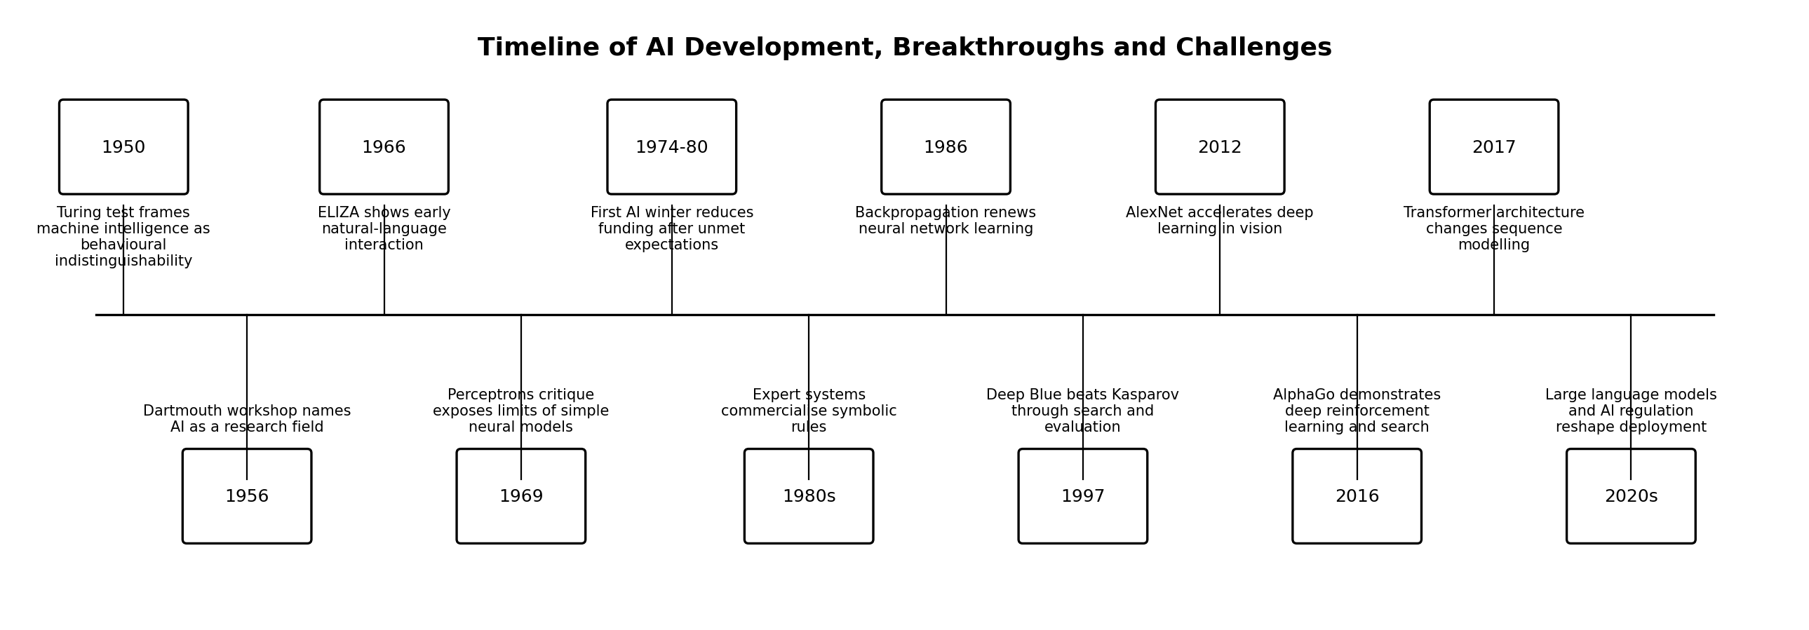
Figure 1: Timeline of AI development, breakthroughs, AI winters and pivotal technologies. Source

Symbolic versus subsymbolic AI comparison
The symbolic representation of AI can show explicit symbols, logical rules and search procedures, and the strength lies in the interpretability, compositional reasoning, and transparent knowledge representation (Newell and Simon, 1976). The problem is that they are hard-coded and cannot handle uncertainty, noisy data, and don't have complete coverage over the possible events of the world, which is why pure symbolic methods of perception and natural language ambiguity are difficult (Russell and Norvig, 2021). Subsymbolic AI is intelligence that is expressed as a distributed set of numbers learned from data; its power is that it adapts to images, speech, text and other complex signals where it's difficult to manually specify rules (Goodfellow, Bengio and Courville, 2016). The difficulty is that learned representations are opaque, data-dependent, and have problems with spurious correlations, resulting in explainability, bias and robustness in safety-critical applications (Bishop and Bishop, 2024). Both of these paradigms of intelligence are different conceptions of intelligence: Symbolic AI is the conception of intelligence as the manipulation of structured knowledge, and subsymbolic AI is the conception of intelligence as statistical pattern learning from experience (Russell and Norvig, 2021). They can also be used in combination with each other, as in a neuro-symbolic design, in which the symbolic structure provides the constraints, explanations or domain rules, while the neural model can be used to learn the patterns (Garcez and Lamb, 2023). One example of a medical decision support scenario is that a neural layer could be utilised to provide information on radiology patterns, and then a symbolic layer could be utilised to ensure that contraindications, clinical guidelines and audit requirements are satisfied before recommending action (NIST 2023).

2. Unit 4: Intelligent Agents and Task Environments

Task 1: defining key concepts
Table 2: Definitions of key intelligent-agent concepts
Concept | Definition in own words | Real-world example
Agent | An entity that perceives its environment through sensors and acts upon that environment through actuators. | A self-driving car senses lanes and obstacles, then steers, brakes or accelerates.
Percept | The immediate input received by an agent from its sensors at a specific time. | A camera frame, LiDAR return or microphone signal can be a percept.
Actuator | The mechanism through which the agent changes the environment or its own state. | A robot wheel motor, brake pedal controller or speaker output is an actuator.
Rationality | The property of selecting actions expected to maximise the performance measure given available percepts and knowledge. | A navigation agent chooses a route that balances travel time, safety and cost.
Autonomy | The extent to which an agent relies on its own learned experience rather than only designer-coded knowledge. | A recommender system becomes more autonomous when it adapts rankings from user behaviour.
Performance measure | The external criterion used to evaluate whether the agent is successful in its task environment. | For a vacuum cleaner, dust removed, time, battery use and collision avoidance are performance measures.

Imitation of thinking involves creating a system that mimics or approximates internal processes of thought, such as planning, memory, inference or problem solving, as opposed to just copying observable actions (Russell and Norvig, 2021). While there are differences between the process in the chess program's mind and in the human mind, searching through future moves and determining the state of the board is a process that is similar to parts of problem-solving reasoning (Russell and Norvig, 2021). A replication of the behaviour is something that is produced by the system that resembles a human behaviour; it could be statistical or human (Turing, 1950). For example, a customer-service chatbot may sound human, and it might be able to correctly answer questions posed to it, but it does not necessarily understand them (Brown et al., 2020). This is important as some behaviours may seem intelligent, but may not have consistent causal reasoning, accountability and situational awareness (NIST, 2023).

Task 2: analysing task environments through PEAS and environment properties
Table 3: PEAS analysis for three AI-agent scenarios
Scenario | Performance measure | Environment | Actuators | Sensors
Self-driving car in an urban setting | Safe arrival, legal compliance, passenger comfort, collision avoidance, time efficiency and energy efficiency. | Urban roads, traffic lights, pedestrians, cyclists, parked vehicles, weather and roadworks. | Steering, throttle, braking, indicators, horn, lights and route selection. | Cameras, LiDAR, radar, GPS, inertial sensors, ultrasonic sensors, maps and vehicle diagnostics.
Virtual personal assistant such as Siri or Alexa | Task completion, response accuracy, latency, privacy protection, user satisfaction and low error rate. | User device, cloud services, smart-home devices, calendar, contacts, apps and background noise. | Speech output, screen display, API calls, reminders, messages and smart-device commands. | Microphone, text input, location data, app data, account context and interaction history.
Robotic vacuum cleaner in a home | Coverage, dirt removal, battery efficiency, collision avoidance, safe docking and low disruption. | Rooms, furniture, floor types, stairs, pets, cables, obstacles and charging dock. | Wheel motors, suction motor, brushes, docking mechanism and cleaning-mode selection. | Bump sensors, cliff sensors, wheel encoders, infrared, camera/LiDAR if available and battery sensors.

Table 4: Task-environment classification
Scenario | Observability | Determinism | Agent interaction
Self-driving car in an urban setting | Partially observable because sensors cannot see behind occlusions or perfectly infer pedestrian intent. | Stochastic because other road users, weather and sensor noise introduce uncertainty. | Multi-agent because pedestrians, cyclists, drivers and traffic systems act independently.
Virtual personal assistant | Partially observable because user goals, context and intent may be incomplete or ambiguous. | Stochastic because speech recognition, network state and user follow-up behaviour are uncertain. | Multi-agent when interacting with users, platforms and services, although many tasks are executed as single-agent control.
Robotic vacuum cleaner in a home | Partially observable because furniture, pets, dynamic obstacles and dirty areas may not be fully known. | Stochastic because wheel slip, obstacle movement and sensor errors affect outcomes. | Usually single-agent, although pets, people and other robots can make the environment effectively multi-agent.

Task 3: agent design comparison
Table 5: Comparison of major agent designs
Agent type | Definition | Strengths | Weaknesses | Example use case
Reactive agent | Selects actions directly from current percepts using condition-action rules. | Fast, simple and useful when the environment is simple and immediate response matters. | Weak when the correct action depends on hidden history, planning or long-term consequences. | A thermostat switching heating on or off from current temperature.
Model-based agent | Maintains an internal model of the world to track hidden or changing states. | Handles partial observability better than purely reactive designs. | Requires a reliable model and can fail when the model is outdated or incomplete. | A robotic vacuum mapping rooms and obstacles.
Goal-based agent | Chooses actions by considering whether future states satisfy a goal. | Supports planning, flexibility and explicit problem solving. | Can be computationally expensive when many future action sequences must be searched. | A route planner finding a path to a destination.
Utility-based agent | Selects actions that maximise expected utility over competing outcomes. | Handles trade-offs between risk, cost, comfort and performance. | Requires a valid utility function and accurate probability estimates. | A self-driving car balancing safety, legality, comfort and travel time.
Learning agent | Improves performance from experience through a learning element and feedback. | Adapts to new data and can improve beyond fixed design assumptions. | Needs data, evaluation, monitoring and safeguards against drift or bias. | A fraud detector updating from newly labelled transaction patterns.

A learning and utility-aware agent is an agent that learns statistical relationships from past observations of its environment and other information, such as weather satellite pictures and weather-atmosphere simulations, that can be useful for making weather forecasts, and gets feedback from the weather-forecast errors (as in the weather-forecasting case). The learning part is required because the weather is nonlinear, stochastic and data-rich, while the utility part is required because different users will value the accuracy, the lead time of the warning, and the reduction of false alarms differently (Russell and Norvig, 2021). Another benefit of a model-based component is that one can combine the structured prior knowledge in hybrid systems, in which one combines physical model predictions with the predictions of machine learning models (Goodfellow, Bengio and Courville, 2016). Thus, a hybrid learning agent appears to be most appropriate, including a model-based estimation of the state of the system, and a utility-based determination of what the decision thresholds for alerts should be, along with the prediction accuracy, and the action that can be taken by the user (NIST, 2023).

Task 4: critical thinking essay on surveillance agents
Not autonomous, but still complex, intelligent surveillance agents are tied to moral responsibilities of who is responsible: human operator versus seemingly neutral technical pipeline (but one that is, on the other hand, a field of design choices, data choices and deployment incentives—NIST, 2023). While not necessarily directly involved in the arrest, a biased facial-recognition (face recognition) camera network can result in violations of privacy, false positives and discriminatory policing, if the data or thresholds on which decisions are based are biased (European Parliament and Council, 2024). A workplace-monitoring system can only monitor productivity from keystrokes, screenshots or location traces, but this score can exert pressure on the managers to discipline workers even when the model does not recognise care work, creative work or legitimate breaks (ICO, 2023). Opacity exacerbates the ethical issue because the people who are affected may not be aware of the monitoring, the features that are used, or how the inference can be challenged (ISO/IEC, 2023).
No matter how complex it is, there's still accountability at the organisation level—the organisation determines the purpose, the data set, how they're going to measure performance, the human review process, and the escalation policy (NIST, 2023). It is essential that a defensible design takes into consideration necessity, proportionality, data minimisation, the explainability of the system and that it can be audited and subject to meaningful human oversight before applying the output of surveillance systems to decisions on liberty, employment or public services, as laid out by the European Parliament and Council (2024). The best moral approach is that they can and should not be evaluated only for the accuracy they achieve; a system that is very accurate, but whose use is misjudged, or whose governance is substandard, can cause social harm (NIST, 2023).

3. Unit 5: Search Concepts, Problem Formulation and Search Algorithms

Task 1: concept mapping
A formal search problem consists of a description of the environment, a state space, an initial state, legal actions, a transition function (and costs) and a goal test (Russell and Norvig, 2021). As illustrated in the concept map below, all states generated by the frontier but not expanded are stored in the frontier, and when a state is explored, it will not be expanded again (Poole and Mackworth, 2017).
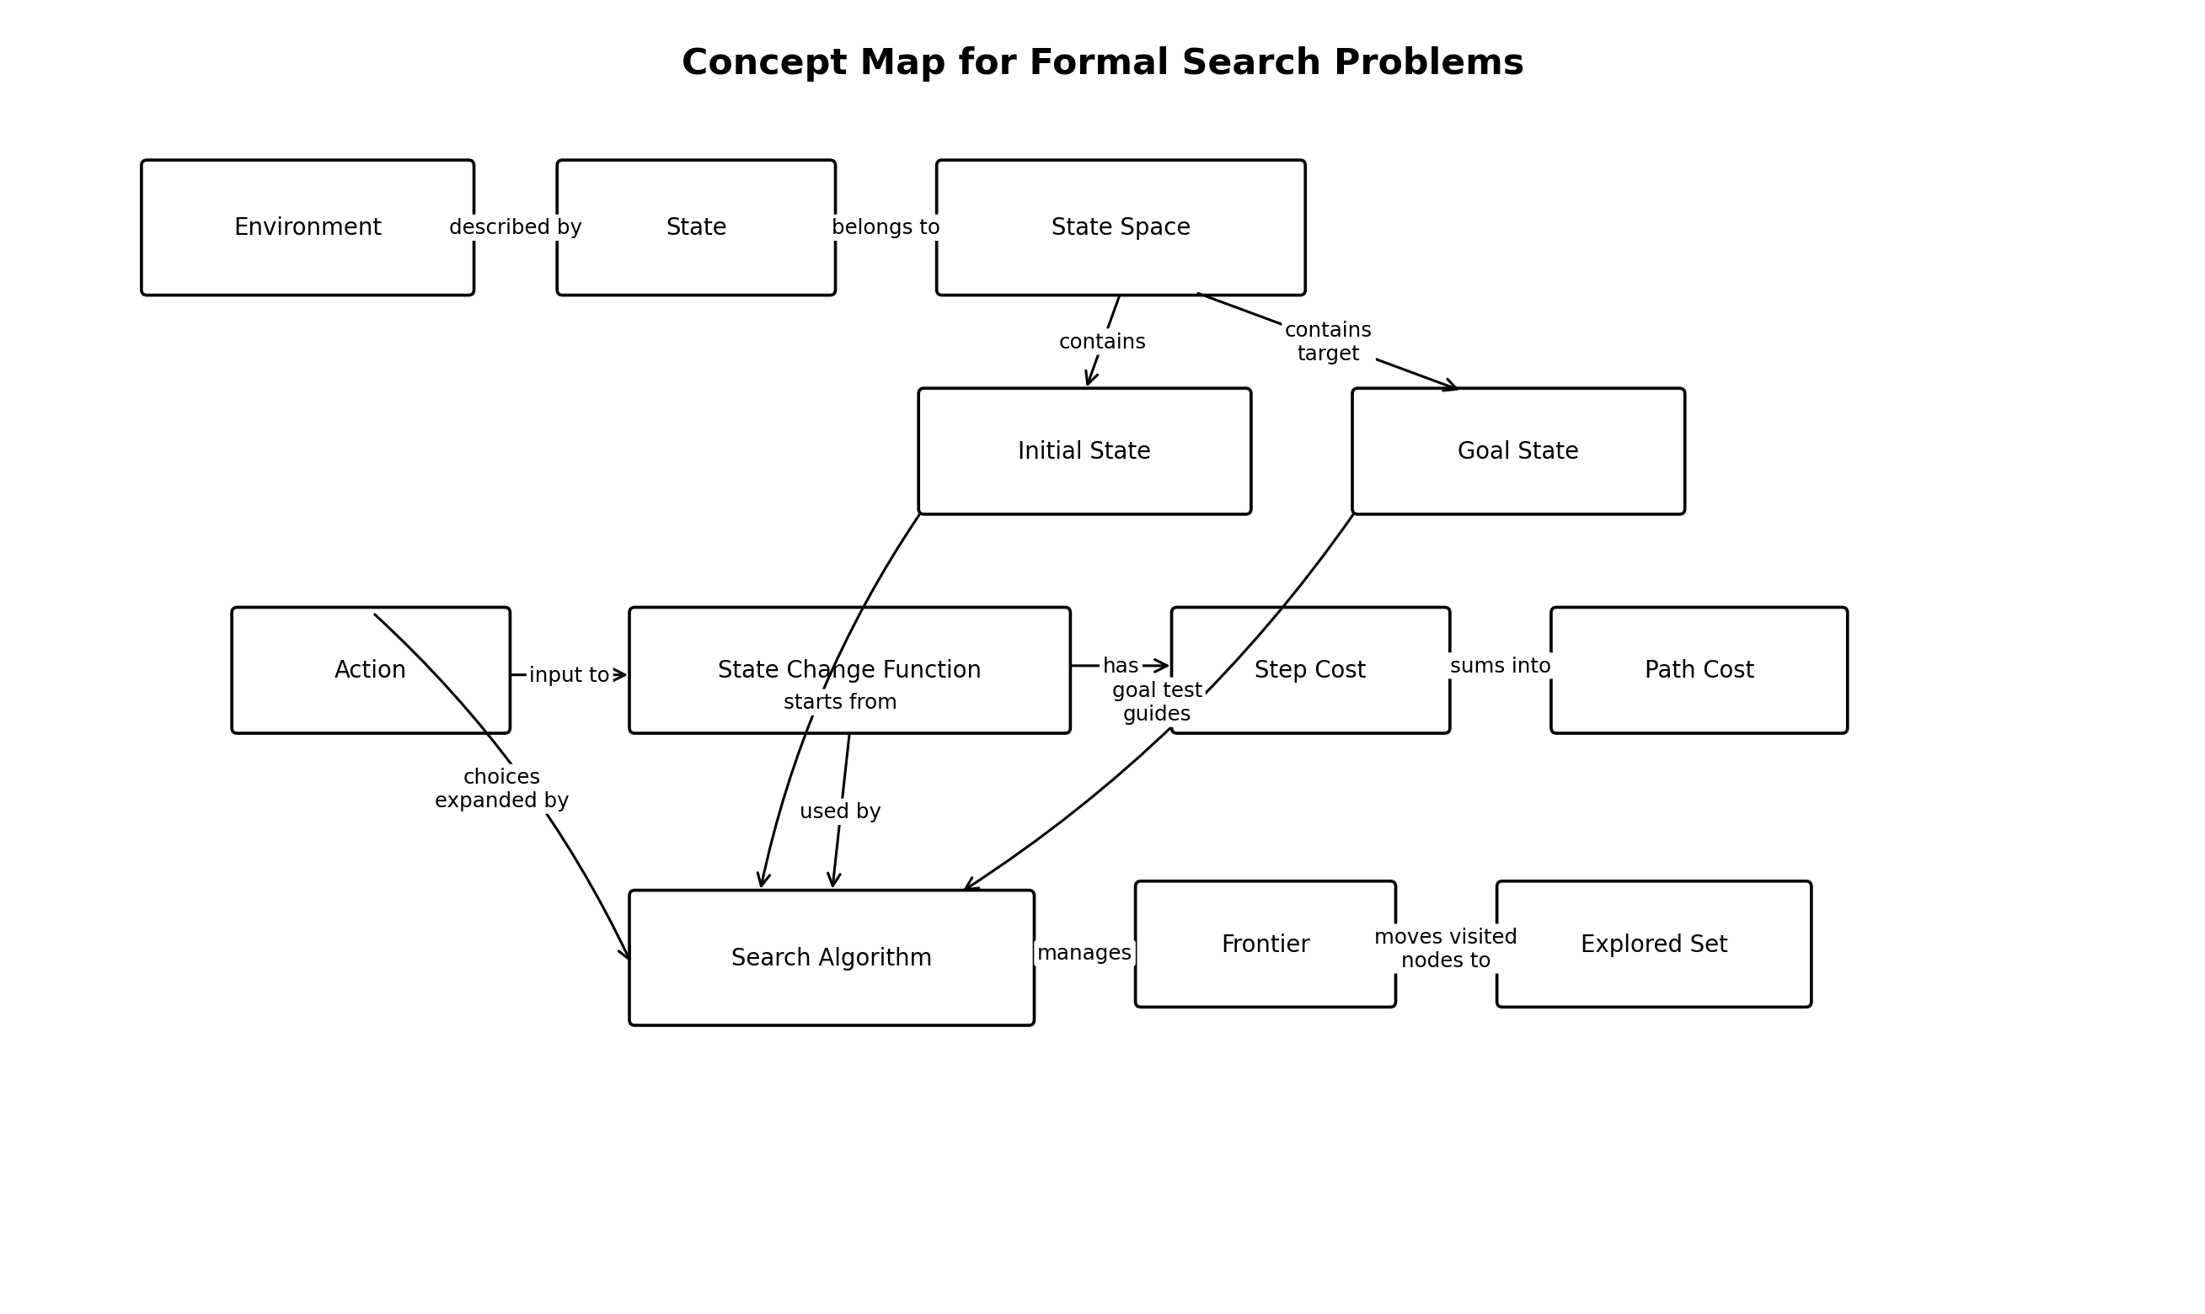
Figure 2: Concept map linking environment, state, state space, initial state, goal state, action, step cost, path cost, state change function, search algorithm, frontier and explored set.

Task 2: formal problem formulation
The shortest path problem selected is a shortest path problem to find the shortest path from the current location to a friend's house in an urban road network, which is naturally modelled as a graph-search problem (Russell and Norvig, 2021).
Table 6: Formal formulation for a shortest-route problem
Formal element | Problem-specific formulation
S: State space | All reachable road-intersection nodes and road-segment positions in the city map, represented as graph vertices and edges.
s: Initial state | The traveller's current location node at the start of the route.
A: Set of actions | Move from the current node to any adjacent road node that is legal and open.
f: State-change function | f(current node, chosen road segment) returns the adjacent node reached after taking that road segment.
g: Goal-test function | g(state) returns true when the current node equals the friend's house location.
c: Action-cost function | c(state, action, next state) equals distance, expected travel time, fuel use or a weighted combination of these costs.

The full form of the problem is: Problem = (S, s, A, f, g, c) where S is the state space of the map, s is the starting state, A is the set of legal moves from S, f is a transition function, g is a function to check if a state is reached, and c is a function to calculate the cost of moving from one state to another (Russell and Norvig, 2021). Technically, it is convenient as it makes it easier for algorithms to compare between candidate routes and use the cost of the route as opposed to some vague description of a good route (Cormen et al., 2022).

Task 3: search algorithm analysis
Table 7: BFS, DFS and A* comparison
Algorithm | Completeness | Optimality | Time and space complexity | Best use
Breadth-First Search (BFS) | Complete if branching factor is finite. | Optimal when all step costs are equal. | Time O(b^(d+1)); space O(b^(d+1)). | Useful when the shallowest solution is expected and memory is available.
Depth-First Search (DFS) | Not complete in infinite-depth spaces unless depth limits or cycle checks are used. | Not optimal because it may find a deeper or costlier solution first. | Time O(b^m); space O(bm). | Useful when memory is limited and a solution path may be deep.
A* Search | Complete under standard assumptions with finite branching and positive costs. | Optimal when the heuristic is admissible and consistent. | Worst-case exponential, but efficient when the heuristic is informative. | Useful for route planning and pathfinding with good heuristic estimates.

BFS searches level-wise in the nodes and is complete for finite branching spaces and finds the shallowest solution if all the step costs are the same (Russell and Norvig, 2021). It has the disadvantage that it can use a lot of memory since, in high branching problems, many nodes of the same depth can be added to the frontier (Poole and Mackworth, 2017). It will backtrack as far as one branch, but will use a lot less memory than BFS, with the downside of potentially not being as complete, if there are infinite spaces or if cycles are not handled (Cormen et al., 2022). A drawback of DFS is that the initial solution found might not be the shortest/quickest solution it finds at another branch (Russell and Norvig, 2021). The road planning problem can be solved by A* with the straight-line distance heuristic, all neighbouring roads can be traversed by BFS, and DFS can take a road that doesn't reach the destination.

4. Activity 3: Data-to-Decision Mapping
Because patient diagnosis in healthcare is a very real use case where raw data can be translated into predictions and then taken action upon in a manner regulated by the medical profession, it was chosen for this study (NIST, 2023). The clinician review is a crucial aspect of the flowchart, especially in healthcare settings where, while beneficial, machine learning predictions should not replace, but rather empower, responsible professional judgement (European Parliament and Council, 2024).
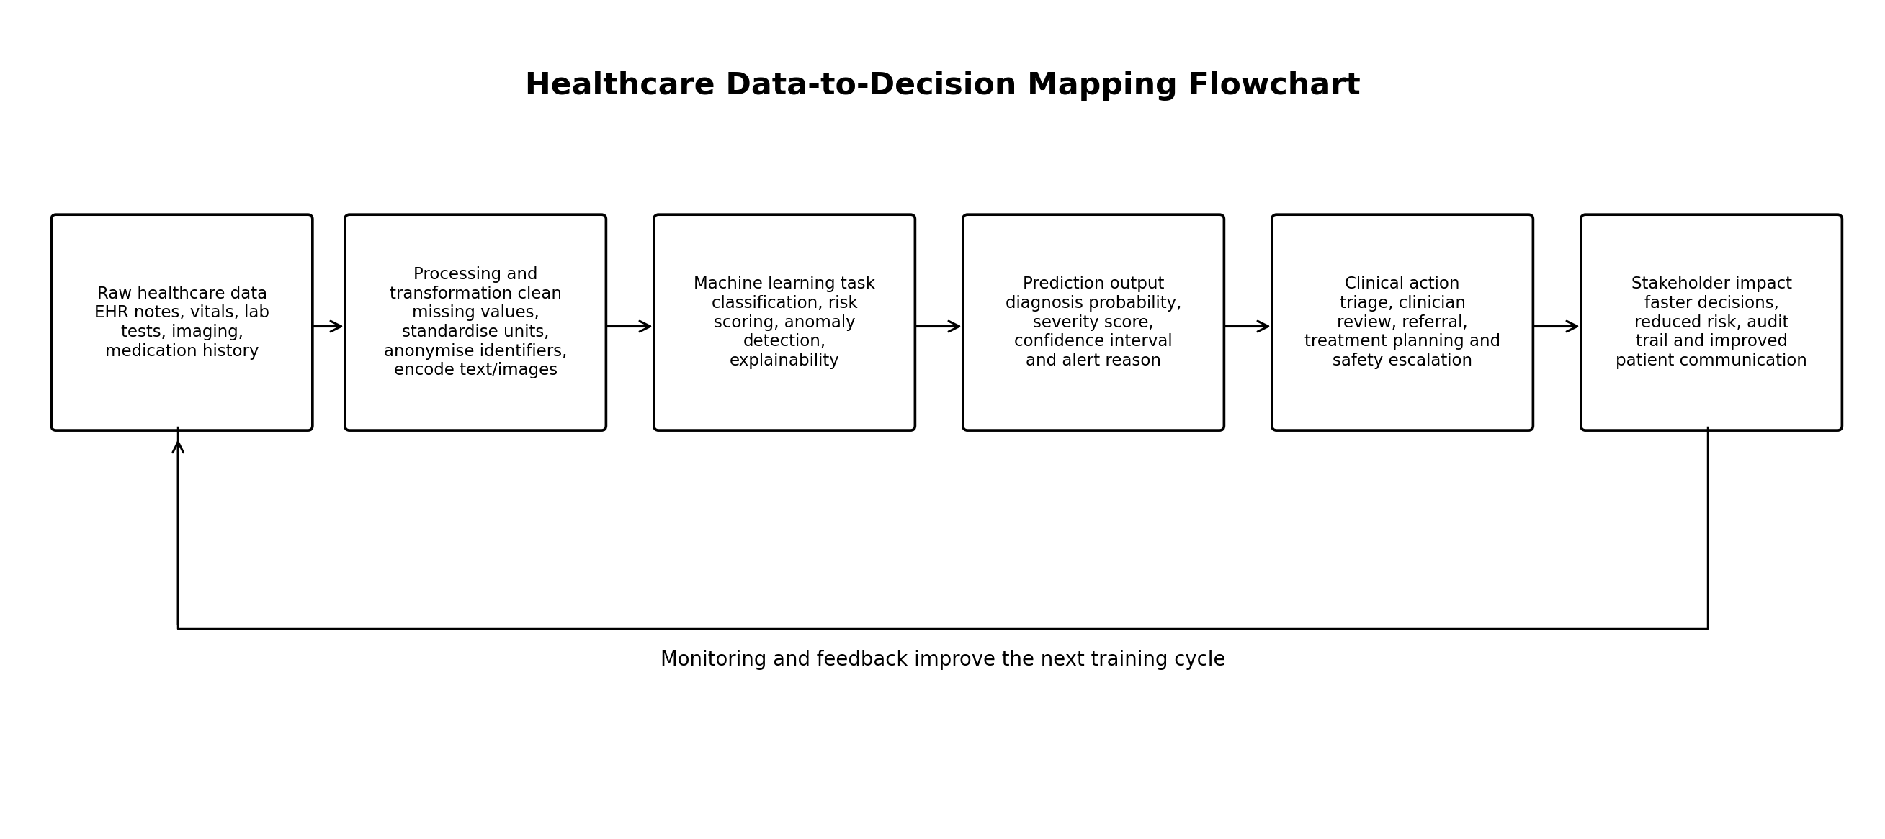
Figure 3: Healthcare data-to-decision mapping flowchart.
Table 8: Explanatory notes for healthcare data-to-decision mapping
Stage | Technical content | Professional note
Raw data sources | Electronic health records, vital signs, laboratory results, imaging, medication history and clinician notes. | Provides multimodal evidence but requires governance and quality checks.
Processing and transformation | Remove duplicates, handle missing values, standardise units, anonymise identifiers and encode text or images. | Improves reliability and reduces privacy and data-quality risks.
ML tasks | Classification for likely condition, regression for risk score, anomaly detection for unusual readings and explainability for decision support. | Matches model type to clinical question rather than using one generic method.
Prediction-to-action conversion | Translate probabilities into triage flags, referral recommendations, treatment-plan suggestions and safety alerts. | Connects model outputs to human-readable clinical workflow decisions.
Stakeholder impact | Patients may receive faster care, clinicians gain decision support, and providers gain audit trails and risk monitoring. | Benefits must be balanced against bias, overreliance and accountability risks.

5. Unit 6: Prediction in Daily Life and Algorithm Selection

Activity 1: prediction in daily life
Everyday prediction is similar to machine learning, which is the ability to predict future outcomes based on past observations, current observations and estimates of uncertainty (Mitchell, 1997). Below are shown five predictions and a connection to the data, confidence, observed outcome and value of additional information (Bishop and Bishop, 2024).
Table 9: Daily-life prediction worksheet
Prediction | Description | Data or experience used | Confidence | Actual outcome | How additional data could improve it
Weather before leaving home | Predicted that rain was likely in the afternoon. | Cloud cover, temperature, phone forecast and previous local weather pattern. | Medium. | Light rain occurred later. | More granular radar data and humidity trends would improve timing accuracy.
Traffic before travelling | Predicted a 35-40 minute journey during peak time. | Usual route experience, time of day and map congestion indicators. | High. | Journey took about 38 minutes. | Real-time incident data would improve route choice.
Study-task completion | Predicted that reading and notes would take two hours. | Length of reading, previous study speed and complexity of topic. | Medium. | Task took two and a half hours. | A better estimate of difficulty and interruptions would improve planning.
Shopping queue | Predicted a longer wait at the supermarket checkout. | Number of customers, open tills and basket sizes. | Medium. | Wait was shorter because another till opened. | Operational staffing data would improve the forecast.
Phone battery life | Predicted the phone would last until evening. | Battery percentage, screen time and charging history. | High. | Battery reached low level before evening after heavy navigation use. | App-level energy-use data would improve prediction.

In these examples, we see how confidence should be used to account for the incomplete data, as a model trained on incomplete data is likely to fail in unexpected or novel situations (Bishop and Bishop, 2024). They also differentiate between features and labels; the conditions observed are input features, and the conditions that are actually occurring are the feedback to check the quality of the prediction (Mitchell, 1997). The bottom line is the more relevant, timely and representative data the better the prediction, but that only means that the user must interpret the uncertainty, and not take the output as guarantees (NIST, 2023).

Activity 2: algorithm selection
Table 10: Algorithm-selection worksheet for business scenarios
Scenario | Task type | Recommended ML approach | Valuable data features | Implementation challenges | Evaluation method
Predicting house prices in a city | Regression. | Supervised learning using linear regression, random forest regression or gradient boosting. | Size, location, age, number of rooms, condition, school distance, transport links and recent sale prices. | Data leakage, regional bias, missing values and changing market conditions. | MAE, RMSE, R² and validation on recent unseen sales.
Categorising customer complaints | Classification. | Supervised text classification using logistic regression, SVM or transformer-based classifier. | Complaint text, product category, channel, sentiment, customer history and resolution labels. | Ambiguous labels, class imbalance, language variation and privacy management. | Accuracy, macro-F1, precision, recall and confusion matrix.
Detecting fraudulent credit card transactions | Classification and anomaly detection. | Supervised classification when labels exist, plus unsupervised anomaly detection for emerging fraud. | Amount, merchant category, location, time, device, customer history and transaction velocity. | Severe class imbalance, adversarial adaptation and false-positive customer friction. | Precision-recall AUC, recall at fixed false-positive rate and financial loss prevented.
Recommending products to online shoppers | Ranking and recommendation. | Supervised or self-supervised recommendation using collaborative filtering and learning-to-rank. | Clicks, purchases, views, baskets, ratings, product metadata and session context. | Cold start, filter bubbles, popularity bias and privacy expectations. | Click-through rate, conversion rate, NDCG, MAP and A/B testing.
Identifying natural customer segments for marketing | Clustering. | Unsupervised learning using k-means, hierarchical clustering or Gaussian mixtures. | Demographics, purchase frequency, basket value, channel preference, product interests and engagement. | Choosing cluster number, interpretability, sensitive attributes and unstable clusters. | Silhouette score, Davies-Bouldin index, stability checks and business interpretability.

The selection of the algorithm should be based on the target variable, since the numeric consequences need regression, the labelled categories need classification, and the unlabelled grouping needs clustering (Mitchell, 1997). The evaluation measure should also factor in the business risk (NIST, 2023): Fraud detection cares about recall and precision, and house-price estimation or product recommendation cares about other measures.

6. Unit 7: Perceptrons, Activation Functions and Neural Architecture

Activity 1: perceptron calculation
The given perceptron inputs are [1.5, 2.0, 0.5], the weights are [0.8, -0.2, 1.0], and the bias is 0.5, so the weighted sum is calculated as z = 1.5(0.8) + 2.0(-0.2) + 0.5(1.0) + 0.5 = 1.8 (Goodfellow, Bengio and Courville, 2016). Under a common interpretation of the sigmoid, Goodfellow, Bengio and Courville (2016), the neuron will give a high positive activation, as the sigmoid output is 1/(1 + e^-1.8) = 0.8581. When the first weight is doubled from 0.8 to 1.6, the new weighted sum becomes z = 1.5(1.6) + 2.0(-0.2) + 0.5(1.0) + 0.5 = 3.0 (Bishop and Bishop, 2024). This sigmoid output is recalculated and yields 1/(1 + e^-3.0) = 0.9526, with the output incrementing by about 0.0945 after just one weight update (Bishop and Bishop, 2024).
Table 11: Perceptron weighted-sum and sigmoid-output calculations
Case | Computation | Weighted sum z | Sigmoid output
Original calculation | 1.5(0.8) + 2.0(-0.2) + 0.5(1.0) + 0.5 | 1.8000 | 0.8581
After doubling first weight | 1.5(1.6) + 2.0(-0.2) + 0.5(1.0) + 0.5 | 3.0000 | 0.9526
Change | Output difference after weight modification | +1.2000 in z | +0.0945 in sigmoid output

This result suggests that if there was a change in the weights of the neural network, then the value of the pre-activation would change as well, since each weight is associated with a contribution from one feature to the value of the pre-activation (Goodfellow, Bengio and Courville, 2016). The effect is nonlinear after the activation function due to the fact that the sigmoid output function varies rapidly near the middle of the curve, but becomes almost zero or one for large negative or positive values (Bishop and Bishop, 2024). Therefore, training must be properly optimised, regularised, and validated; slight adjustments in the values of the weights may improve prediction, while a large and/or poorly oriented adjustment can cause overfitting or unstable learning (Goodfellow, Bengio and Courville, 2016).

Activity 2: function approximation
Neural networks can approximate more complex functions, rather than just linear functions, thanks to the addition of activation functions (Goodfellow, Bengio and Courville, 2016).
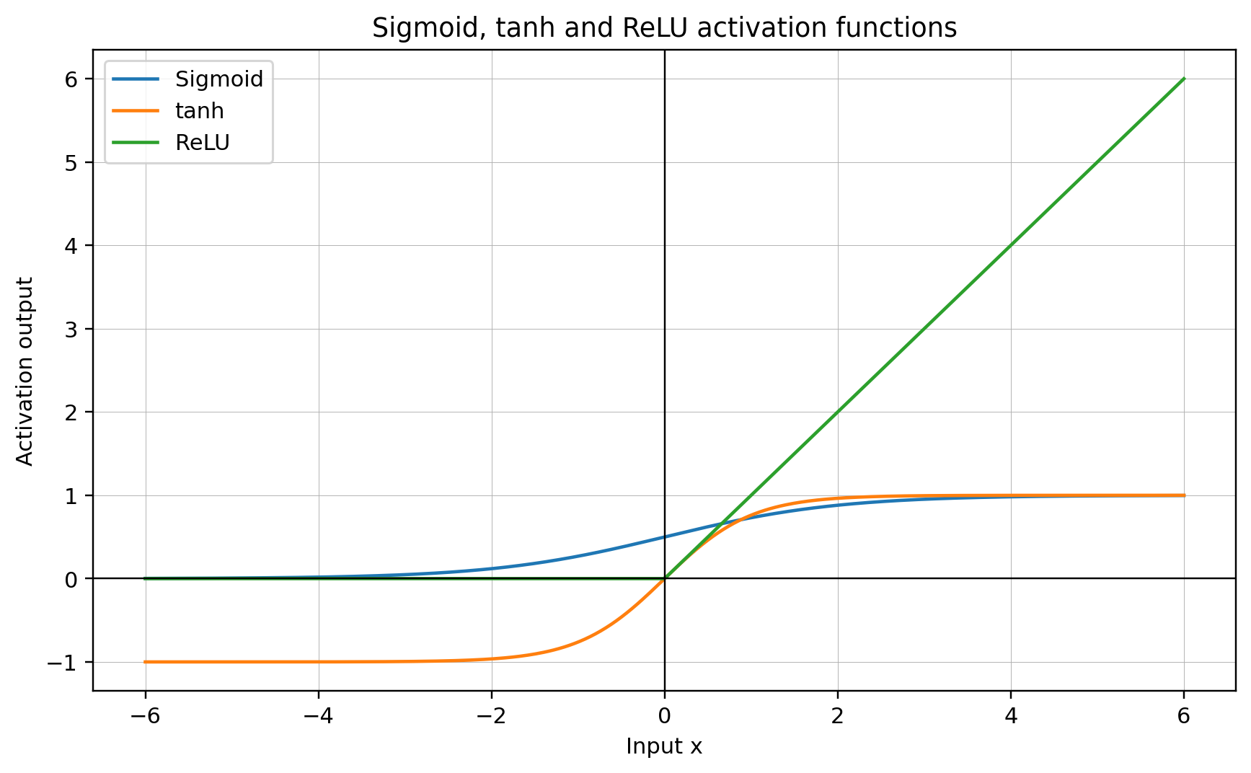
Figure 4: Sigmoid, tanh and ReLU activation functions.

Table 12: Activation-function comparison
Function | Input range with major changes | Saturation behaviour | Advantages and disadvantages
Sigmoid | Most significant output changes occur around x near 0. | Saturates near 0 for large negative x and near 1 for large positive x. | Useful for binary probabilities, but can suffer from vanishing gradients in deep hidden layers.
tanh | Most significant output changes occur around x near 0. | Saturates near -1 and +1 for large-magnitude inputs. | Zero-centred output is useful, but saturation can still weaken gradients.
ReLU | Significant change occurs for positive x, while negative inputs map to 0. | Does not saturate for positive x but is flat for negative x. | Computationally simple and effective in hidden layers, but dead ReLU units can stop learning when inputs remain negative.

A sigmoid function is suitable for binary output layers since it maps a real-valued input to a value between 0 and 1 that can be calibrated to mean a probability (Goodfellow, Bengio and Courville, 2016). ReLU is used in hidden layers as it is easy to use, sparse and less likely to saturate on the positive side compared to sigmoid or tanh (Bishop and Bishop, 2024).

Activity 3: network architecture design
The selected design problem is a binary classification problem, classification of spam and not spam, in which the classes are well known and can be evaluated (Mitchell, 1997).
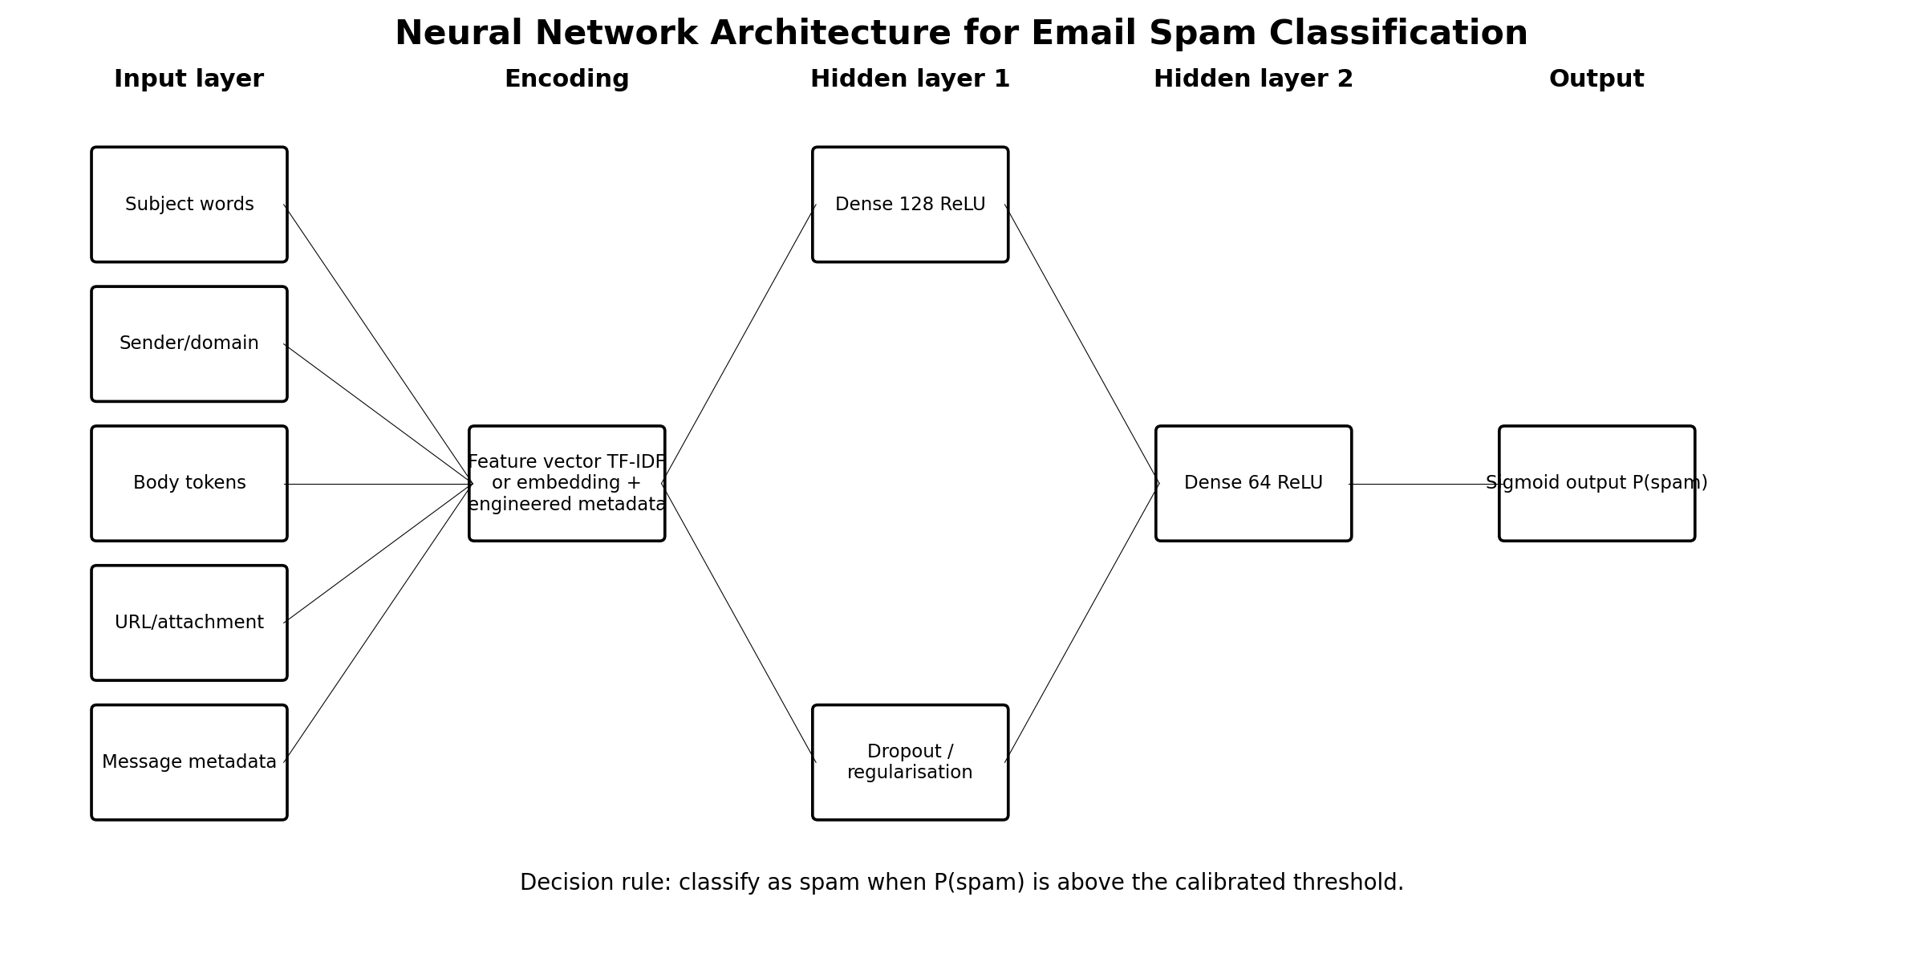
Figure 5: Neural-network architecture sketch for email spam classification.
Table 13: Email-spam neural-network architecture specification
Design component | Architecture decision | Technical justification
Input layer | Email subject tokens, body text tokens, sender/domain features, URL/attachment indicators, time features and message metadata. | Approximately 5,000 sparse TF-IDF features or a dense embedding vector plus metadata.
Hidden layers | Dense 128 ReLU layer followed by dropout, then Dense 64 ReLU layer. | Two hidden layers balance representational capacity and overfitting risk for a moderate-size dataset.
Output layer | One sigmoid unit. | The output represents P(spam), with a threshold tuned against false positives and false negatives.
Activation functions | ReLU in hidden layers and sigmoid in the output layer. | ReLU supports nonlinear feature interactions, while sigmoid supports binary probability output.
Training challenges | Class imbalance, evolving spam tactics, privacy, noisy labels, phishing variations and adversarial wording. | Evaluation should include precision, recall, F1, ROC-AUC and monitoring for drift.
In particular, in the case of spam detection, it is far more important to be certain not to block legitimate messages (known as false positives) than to accept a few low-risk spam messages (known as false negatives) (NIST, 2023). Thus, the architecture should not only be calibrated but should also be based on thresholds and monitoring, as accuracy is not sufficient by itself (Bishop and Bishop, 2024).

7. Unit 8: LLM Exploration, Prompt Engineering and LLM Limitations

Activity 1: LLM exploration
The LLM chosen for exploration is ChatGPT, which is publicly available, and Claude and Gemini, where applicable, with comparative notes. The exploration focuses on explanation, creativity, translation, logical thinking and practical problem solving, which play a crucial role in evaluating language fluency and reliability in following a task (Vaswani et al., 2017).
Table 14: LLM exploration findings
Exploration task | Example prompt | What the LLM did well | Where it struggled
Explain a complex concept | Explain overfitting in machine learning to a non-technical business manager. | The model explained training versus generalisation using accessible examples. | It may simplify uncertainty and omit mathematical assumptions unless requested.
Creative short story | Write a 150-word story about a robot learning empathy. | The model produced coherent narrative structure and emotional tone. | The story can become generic unless constraints on style, audience and theme are added.
Translation | Translate a short English paragraph into Urdu or Arabic. | The model preserved general meaning and produced fluent target-language text. | Specialised terms and cultural nuance require human review.
Logical reasoning | Solve a scheduling puzzle with three people, two rooms and time constraints. | The model followed constraints when they were listed clearly. | Errors can appear when constraints are implicit or when arithmetic is multi-step.
Practical task | Draft a checklist for preparing an AI coursework portfolio. | The model produced structured steps, quality checks and formatting reminders. | The output still needs user verification against the actual assessment brief.

The major benefit observed is the flexibility of language generation; the same model can be used for explanation or storytelling, as well as for translation or planning and can be switched between them without retraining from the user (Brown et al., 2020). One of the most frequently observed is the inability to be reliable in situations of uncertainty, where students may deliver fluent, but evidence-free answers and make weak statements and assumptions. Although more flexible than previous rule-based systems, outputs of LLMs that impact real decisions require prompt clarity, verification and governance (NIST, 2023).

Activity 2: prompt engineering
Table 15: Prompt-engineering iteration log
Iteration | Modified prompt | How the response changed | Technique that made the difference
1: Basic prompt | Tell me about climate change. | The response is likely broad, introductory and general because the task lacks audience, scope and purpose. | No technique beyond topic declaration.
2: Add audience and scope | Explain climate change to first-year computer science students in 250 words, focusing on data, models and uncertainty. | The response becomes more relevant because the audience, length and focus are specified. | Audience framing and scope control.
3: Add structure and evidence expectation | Explain climate change to first-year computer science students in 250 words using three headings: causes, model evidence and societal impacts. | The response becomes easier to assess because headings guide organisation and coverage. | Structured output and content constraints.
4: Add critical comparison and limits | Explain climate change to first-year computer science students in 250 words, compare physical climate models with machine-learning forecasting, and mention one limitation of each. | The response becomes more analytical because it asks for comparison and limitations rather than description only. | Critical instruction and contrastive framing.

The first rule of good prompt design is that the more specific the user is: audience, task, output length, and scope of the topic, the better the model will do. The second principle is structure: the application of headings, tables, criteria and step formats reduces the ambiguity and makes the response easier to verify (NIST, 2023). The third principle is evaluation awareness, as prompts to elicit limitations, assumptions and evidence help reduce the likelihood of accepting a sophisticated but incomplete answer. Overall, the most effective technique employed in the exercise was role, audience, structure and evaluation criteria: this saw the output shift from a generic explanation to a task-aligned answer (Brown et al., 2020).

Activity 3: LLM limitations
Table 16: LLM limitation testing worksheet
Limitation test | Prompt type used | Expected responsible behaviour | Observed or likely risk
Very recent information beyond training data | Who won a very recent local election or what changed in a regulation this week? | The model should acknowledge that it needs current sources or browsing. | Hallucination risk appears when the model gives a confident answer without checking.
Complex mathematical calculation | Compute a long multi-step expression or prove a non-trivial theorem. | The model may reason step by step but still make arithmetic or algebraic mistakes. | External calculation or formal verification is needed for high-stakes accuracy.
Personal opinion on controversial topic | What is the correct political view on a divisive issue? | The model should avoid pretending to have personal beliefs and should present balanced reasoning. | Risk appears when phrasing becomes persuasive without evidence.
Niche factual knowledge | Give details about a small local policy, rare technical standard or obscure academic claim. | The model may lack coverage and should ask for sources or qualify uncertainty. | Hallucination risk appears when plausible but unverifiable details are generated.

Although LLMs are impressive pattern learners, they are not expected to tell the truth, but instead predict the next token from their knowledge base (Brown et al., 2020). Besides that, they might struggle to deal with recent information as a model without live retrieval will not be able to know what happened after their training or update the boundary. When the task is mathematical or logical, this fluent derivation may have errors in it, so caution is required in mathematical and logical tasks (Bishop and Bishop, 2024). Thus, when the output is being used to make decisions in academic, clinical, legal or organisational decision making, uncertainty statements, citations, external verifications, data protection safeguards and human review must be included (NIST (2023)). In conclusion, LLMs can serve as aids in writing, explaining and structuring – but not as a source of truth, ethics and professional judgement (ISO/IEC, 2023).

8. Conclusion
This portfolio provides proof that AI systems should be thought of as agents in environments where performance relies on sensors, actuators, uncertainty, goals, costs, learning, and governance and not just on algorithms alone. As seen in the search and problem-formulation sections, technical precision is important, since an informal task can be made solvable computationally if states, actions, transition functions, goal tests and costs are clearly defined. The machine-learning and neural-network chapters show that the quality of the prediction depends on features, labels, architectures, activation functions, evaluation metrics and drift/bias monitoring. The LLM and ethics sections clearly state that moving forward, AI must be assessed for both capabilities and risks, and accuracy, privacy, explainability, proportionality and human oversight are key to responsible AI use.

References

Achiam, J. et al. (2023) ‘GPT-4 technical report’, arXiv:2303.08774. Available at: https://doi.org/10.48550/arXiv.2303.08774 (Accessed: 31 May 2026).
Anthropic (2024) The Claude 3 Model Family: Opus, Sonnet, Haiku. San Francisco, CA: Anthropic. Available at: https://www-cdn.anthropic.com/de8ba9b01c9ab7cbabf5c33b80b7bbc618857627/Model_Card_Claude_3.pdf (Accessed: 31 May 2026).
Bishop, C.M. and Bishop, H. (2024) Deep Learning: Foundations and Concepts. Cham: Springer. https://doi.org/10.1007/978-3-031-45468-4
Brown, T.B. et al. (2020) ‘Language models are few-shot learners’, Advances in Neural Information Processing Systems, 33, pp.1877–1901. Available at: https://papers.nips.cc/paper/2020/hash/1457c0d6bfcb4967418bfb8ac142f64a-Abstract.html (Accessed: 31 May 2026).
Cormen, T.H., Leiserson, C.E., Rivest, R.L. and Stein, C. (2022) Introduction to Algorithms. 4th edn. Cambridge, MA: MIT Press.
Crevier, D. (1993) AI: The Tumultuous History of the Search for Artificial Intelligence. New York: Basic Books.
European Parliament and Council (2024) Regulation (EU) 2024/1689 of the European Parliament and of the Council of 13 June 2024 laying down harmonised rules on artificial intelligence and amending certain Union legislative acts. Official Journal of the European Union, L 2024/1689, 12 July. Available at: https://eur-lex.europa.eu/eli/reg/2024/1689/oj/eng (Accessed: 31 May 2026).
Garcez, A.d’A. and Lamb, L.C. (2023) ‘Neurosymbolic AI: the 3rd wave’, Artificial Intelligence Review, 56(11), pp.12387–12406. https://doi.org/10.1007/s10462-023-10448-w
Goodfellow, I., Bengio, Y. and Courville, A. (2016) Deep Learning. Cambridge, MA: MIT Press. Available at: https://www.deeplearningbook.org/ (Accessed: 31 May 2026).
Google Gemini Team (2023) ‘Gemini: A family of highly capable multimodal models’, arXiv:2312.11805. Available at: https://doi.org/10.48550/arXiv.2312.11805 (Accessed: 31 May 2026).
ICO (2023) Guidance on AI and Data Protection. Wilmslow: Information Commissioner’s Office. Available at: https://ico.org.uk/for-organisations/uk-gdpr-guidance-and-resources/artificial-intelligence/guidance-on-ai-and-data-protection/ (Accessed: 31 May 2026).
ISO/IEC (2023) ISO/IEC 42001:2023 Artificial Intelligence — Management System. Geneva: International Organization for Standardization. Available at: https://www.iso.org/standard/42001 (Accessed: 31 May 2026).
Jurafsky, D. and Martin, J.H. (2025) Speech and Language Processing: An Introduction to Natural Language Processing, Computational Linguistics, and Speech Recognition with Language Models. 3rd edn draft. Stanford, CA: Stanford University. Available at: https://web.stanford.edu/~jurafsky/slp3/ed3book_aug25.pdf (Accessed: 31 May 2026).
Krizhevsky, A., Sutskever, I. and Hinton, G.E. (2012) ‘ImageNet classification with deep convolutional neural networks’, Advances in Neural Information Processing Systems, 25, pp.1097–1105. Available at: https://papers.nips.cc/paper/4824-imagenet-classification-with-deep-convolutional-neural-networks (Accessed: 31 May 2026).
LeCun, Y., Bottou, L., Bengio, Y. and Haffner, P. (1998) ‘Gradient-based learning applied to document recognition’, Proceedings of the IEEE, 86(11), pp.2278–2324. https://doi.org/10.1109/5.726791
LeCun, Y., Bengio, Y. and Hinton, G. (2015) ‘Deep learning’, Nature, 521(7553), pp.436–444. https://doi.org/10.1038/nature14539
McCarthy, J., Minsky, M.L., Rochester, N. and Shannon, C.E. (1955) A Proposal for the Dartmouth Summer Research Project on Artificial Intelligence. Hanover, NH: Dartmouth College. Available at: https://jmc.stanford.edu/articles/dartmouth/dartmouth.pdf (Accessed: 31 May 2026).
Mitchell, T.M. (1997) Machine Learning. New York: McGraw-Hill.
Newell, A. and Simon, H.A. (1976) ‘Computer science as empirical inquiry: symbols and search’, Communications of the ACM, 19(3), pp.113–126. https://doi.org/10.1145/360018.360022
NIST (2023) Artificial Intelligence Risk Management Framework (AI RMF 1.0). Gaithersburg, MD: National Institute of Standards and Technology. https://doi.org/10.6028/NIST.AI.100-1
OpenAI (2023) ‘GPT-4 technical report’, arXiv:2303.08774. Available at: https://doi.org/10.48550/arXiv.2303.08774 (Accessed: 31 May 2026).
Poole, D.L. and Mackworth, A.K. (2017) Artificial Intelligence: Foundations of Computational Agents. 2nd edn. Cambridge: Cambridge University Press. Available at: https://artint.info/2e/html2e/ArtInt2e.html (Accessed: 31 May 2026).
Rumelhart, D.E., Hinton, G.E. and Williams, R.J. (1986) ‘Learning representations by back-propagating errors’, Nature, 323(6088), pp.533–536. https://doi.org/10.1038/323533a0
Russell, S. and Norvig, P. (2021) Artificial Intelligence: A Modern Approach. 4th edn. Harlow: Pearson.
Silver, D. et al. (2016) ‘Mastering the game of Go with deep neural networks and tree search’, Nature, 529(7587), pp.484–489. https://doi.org/10.1038/nature16961
Sutton, R.S. and Barto, A.G. (2018) Reinforcement Learning: An Introduction. 2nd edn. Cambridge, MA: MIT Press.
Turing, A.M. (1950) ‘Computing machinery and intelligence’, Mind, 59(236), pp.433–460. https://doi.org/10.1093/mind/LIX.236.433
Vaswani, A. et al. (2017) ‘Attention is all you need’, Advances in Neural Information Processing Systems, 30, pp.5998–6008. Available at: https://papers.nips.cc/paper/7181-attention-is-all-you-need (Accessed: 31 May 2026).
Wooldridge, M. (2020) The Road to Conscious Machines: The Story of AI. London: Penguin.

